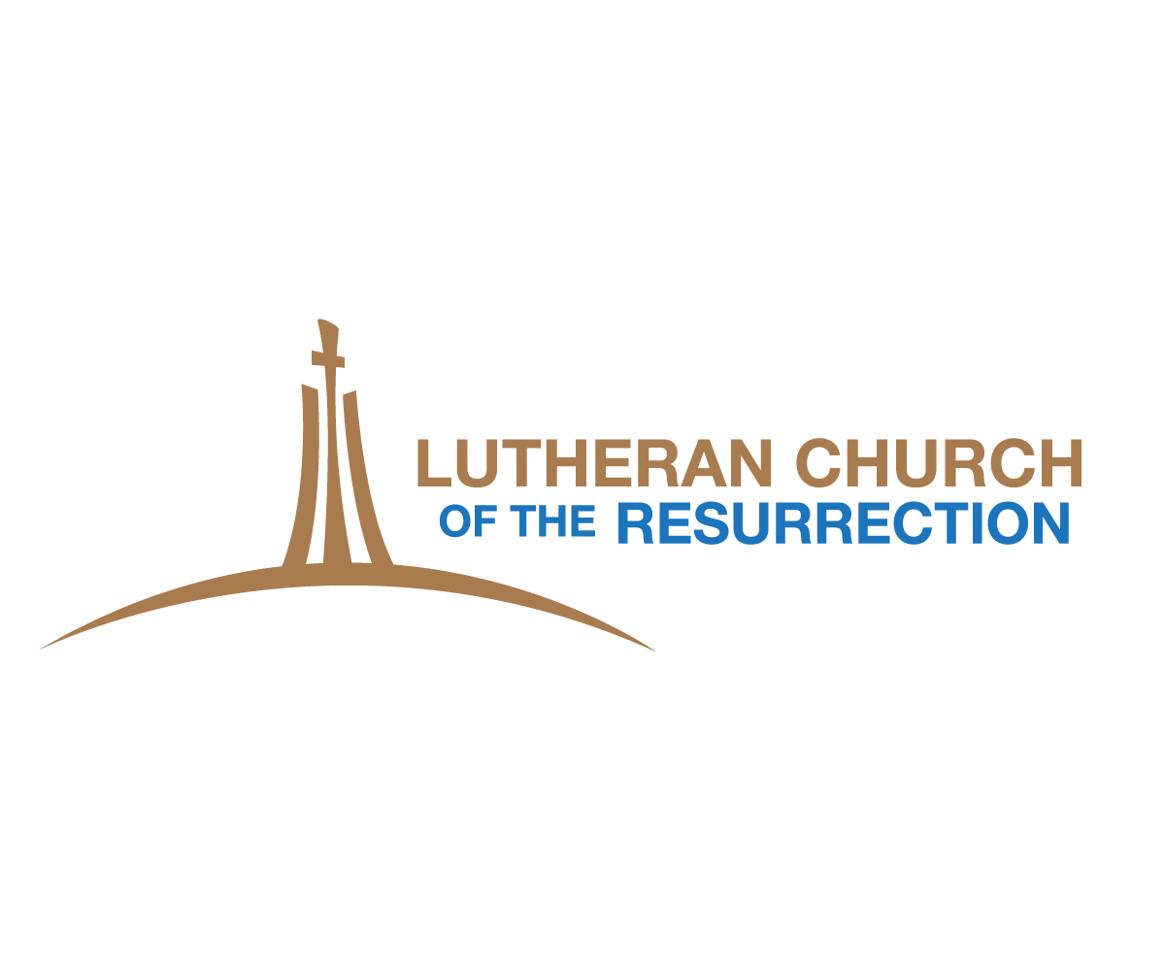

*10th Grade Confirmation Faith Statement*

* Please place your name and contact information on your paper.
* Faith Statements should be about 1-2 pages in length, typed using regular font size 12 point.
* Please use complete sentences, with specific examples. Elaborate as much as possible.
* Please take time to pray about your reflections before you write your reflections on your faith statement.
* Please choose a favorite bible verse(s) for your confirmation day & beyond

***Use the following questions to get ideas:***

* How would you describe God to a friend at school?
* How has your relationship with Jesus changed from Sunday school through today? Why does Jesus matter in your life?
* When have you experienced The Holy Spirit at work in your life and what was it like?
* What was one of the most memorable moments in your confirmation journey?
* How does your faith make a difference in your daily life?
* Will you feel differently once you are confirmed?
* How do you see yourself being involved with the church now and in the future?

**Just a reminder**….your faith statement should be completed by **October 14th** and turned into Pastor Karen. You must also complete a one hour conversation meeting with Pastor Karen during the 2 weeks before Confirmation Sunday. This conversation meeting is for the confirmand, with a parent or guardian also in attendance.

***Please sign-up on Pastor Karen’s office door for you conversation meeting time.***